Evapotranspiration from soil (for Chunping)

Yongbo, 3/11/2010

Soil ET is the evapotranspiration from soil water reservoir. For calculation purpose, this process is assumed to occur after lateral subsurface flow (these two processes together with percolation should occur simultaneously after infiltration). The method relating ET linearly with actual soil moisture used in the original WetSpa will be the default method to estimate actual ET from the soil water reservoir. Other AET methods will be developed in the future as ET options in the system.

- Task: Write a program for actual ET from soil
- Objective: Water balance
- Class: Soil ET
- Method: Linear moisture
- Module name: SET_LM
- Language: C++
- Formulation

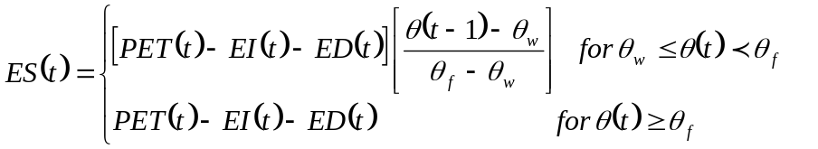

where ES(t) is the actual soil evapotranspiration for the time increment (mm), PET is the potential evapotranspiration (mm), EI is the evaporation from interception storage (mm), ED is the evaporation from depression storage (mm), θ(t-1) is the cell average soil moisture content at time t-1 (initial moisture of the time step), θ_{f} is the soil moisture content at field capacity (m³/m³), and θ_{w} is the soil moisture content at plant permanent wilting point (m³/m³). See WetSpa user manual.

- Input files from Project/model subdirectory:
1). Time step: read from file.in
2). Cell size: read from config.fig (refer to overland flow routing)
3). Fieldcap: field capacity map, read from the ASCII parameter database (fieldcap.asc).
4). Wiltingpoint: wilting point map, read from the ASCII parameter database (wiltingpoint.asc).

These inputs will be done in the “Read-in parameters” subroutine of the Main. Because the Main has not been developed yet, you can input these parameters in your module.

- Inputs from other modules:
1). PET (mm): potential evapotranspiration corrected by the vegetation coefficient, obtained from the PET module.
2). EI (mm): evaporation from interception storage, obtained from the interception module
3). ED (mm): evaporation from depression storage, obtained from the depression module
4). θ(t-1): initial soil moisture of the time step, obtained from the soil water balance module

Because these modules are not ready in use yet, assume some sample maps for your module test.

- Output in /project/model
1). D_SOET: Distribution of soil evapotranspiration for a user defined period.

This output will be done in the “Print-out” subroutine of the Main. Because the Main has not been created yet, you can output this file in your module.

- References
1). WetSpa user manual
2). WetSpa Fortran code model2, evapotranspiration

